|  |  |  |  |  |
| --- | --- | --- | --- | --- |
| Student Details | | | | |
| Family Name: | Ferro | | | |
| Given Name: | Alessandro | | | |
| Subject Details | | | | |
| Qualification: | Diploma of Web Development | | | |
| Unit Code and Title: | ICTTEN516 – Produce technical solutions from business specifications | | | |
| Trainers’ Name: | Ida Ho | | | |
| Assignment Details | | | | |
| Due Date: |  | Assessment No:  (If applicable) | |  |
| Date Submitted: |  | | | |
| Checklist | | | | |
| * I have kept a copy of my assignment before submitting * I have completed and signed this page * I have answered all questions in the assignment * I have attached any relevant evidence/documentation, as required for the assessment | | | | |
| Declaration | | | | |
| I have been advised of the assessment requirements and have been made aware of my rights and responsibilities as an assessment candidate.  I declare that, to the best of my knowledge and belief, this assignment is my own work, all sources have been properly acknowledged, and the assignment contains no plagiarism. This assignment or any part thereof has not previously been submitted for assessment **at this or any other RTO**. | | | | |
| Student’s signature: Alessandro Ferro | | | Date: 08/11/2020 | |

|  |  |  |  |  |
| --- | --- | --- | --- | --- |
|  | | | | |
| **Assessment Feedback** | | | | |
|  | | | | |
|  | | | | |
|  | | | | |
|  | | | | |
|  | | | | |
|  | | | | |
|  | | | | |
|  | | | | |
| **Result** | **Satisfactory** | **Not Satisfactory** | **RPL** | **RCC** |
| **NYC – New assessment date scheduled or FIR – Further information Required** | | | **Date:** | |
| Trainers/Assessors signature: | | | Date: | |
| **Student Comments** | | | | |
|  | | | | |
|  | | | | |
|  | | | | |
| * I have received my assessment result and am satisfied with the feedback given on this assessment | | | | |
| Student’s signature: | | | Date: | |

1.1

Obtain business needs often be documented in the business requirements document or report. The processes and procedures will need to be acquire to form part of the technical requirements.

**Answer**

To fully understand the system to be developed and produce the technical requirements, a developer first must understand the business needs.

The business needs can vary greatly from organization to organization and form project to project, but there are some tasks to help a developer in identifying them:

* Calryfing the business problem
* Identifying the vision or strategic mission
* Identifying the stakeholders
* Documentation.

With the business needs identified and a first draft of the techincal requirements availabe, the developers can proceed to refine the techincal requirements by modelling the system.

There a differrent ways to model a system and chosing the appropriate one largely depends on the kind of system to be developed.

For a website, prototyping woud probably work best. Producing a simple, yet functioning version of the product to introduce to the stakeholders, allows for better contextual communication. The conversation wouldn’t revolve around ambigous concepts and abstract ideas, but would focus on pragmatic aspects of the system that can be pointed at and tested. Another advantage of this technique is that the prototype produced can be evolutionary, meaning that can serve as the actual base onto which the system is implemented.

Other modeling techniques include structured analysis, more suited for data driven applications and object oriented analysis for event driven applications.

Structured analysis relies on tools such as data flow diagrams, context diagrams, data dictionalry, system flow charts and entity relationship diagrams and more.

Object oriented analysis makes use of the unified modelling language (UML) to create use case diagrams, class diagrams, sequence diagrams, activity diagrams and statechart diagrams.

1.2

Write brief summary of business needs involves: clarifying the business problem, identifying the vision or strategic mission, identifying stakeholders and related documentation

**Answer**

* Clarifying the business problem - The main resource that can help the developer here, is the business requirements document. This document contains a problem/opportunity statement, that describes the reasons for the client to develop a new system, and the functional requirements, that describes what the system should do.
* Identifying the vision or strategic mission - It often happens that the new system to be developed is only a part of a bigger, more complex business system. To write accurate technical requirements, a developer needs to have a clear understanding of the processes and procedures that regulate the client operations, and of how the new system will fit in them.
* Identifying stakeholders - Documentation can only give a partial understandig of the system and its needs. The people that will own, use or interact with the system are an important source of information and they should be identifyied and categorized in accordance to their role in the organziation and involvement in the project.
* Documentation - If already available, the developer can refer to the techical requirements document. This can be a document on its own or can be part of the business requirements report, where is often referred to as non-funtional requirements.

1.3

Identify input/output requirements, interface requirements and process requirements. For example hardware or software upgrade, network installation, inventory management and e-commerce solution.

**Answer**

* Technical requirements for Input/Output
  + What kind of interaction process is needed (B2B or B2C)
  + What action starts the interaction
  + What data are required to complete the process
  + How should data be transfered (protocol)
  + How is the input taken and the output provided.
* Interface requirements
  + What kind of source provide the data (human, software, hardware)
  + How are data going to be organized (data items and data structures)
  + How can data be exchanged
  + What method to exchnage data is the most appropriate (manual, upload/download, batches, seamless system exchange)
  + How should data be transfered (protocol)
  + Document the details concerning how data are gathered retrieved and exchanged.
* Technical requirements for processes and quality
  + In what environment will the system run
  + What are the client’s organization policies
  + What are the standards of the client’s industry
  + What boundaries and constraints would the system be subject to
  + What to include in the technical requirements.

1.4

It's necessary to look at the technical requirements in three main of input/output requirements, interface requirements and process requirements.

**Answer**

The goal of information systems is often to achieve the maximum level of automation feasible. For automation to be possible, one of the most important aspect to consider is input/output.

The system will need to interact with various actors that will provide data and will establish to whom the results will have to be returned.

These actors can be other business computer systems such as suppliers, users and customers computer systems and internal systems.

An inherent part of this process is constituted by the methods, formats and protocols adopted for the data exchange. The type of information transferred and who will receive and process those information, will define the detail about the data exchange and should be included in the technical requirements.

For this data to be meaningful and usable, the actors need to be capable of interfacing with each other. There are various options available to implement the interfacing of a system with another system, and they all come with different levels of efficiency, control and security, and the technical requirements for each one of them would differ from the others.

When the interaction is between the system and a human user, what data need to be collected from the user, what data the user should be returned, how to collect and how to display the information from and to the user, would result in considerations regarding security, screens and form design and error handing. In addition, client’s specific requirements, such as color scheme or navigation and more, should also be recorded in the technical requirements.

A system si not defined solely by its interactions, but its boundaries, constraints and the environment in which it will operate, also play a huge role in determining its technical requirements.

These non-functional requirements, which encompasss performance, quality, environmental requirements, size, usability, reliability, robustness and portability, are the characteristics of the system and although they do not determine the system design, they contribute in defining it.

An example of this can be seen for what concerns the envirnmental requirements. They define the hardware the system will run on, the network infrastructure, the operating system, the application architecture, internal and external interface requirements and protocols, development tools and industry standards or guidelines. It’s a long list and each entry contribute in drawing the boundaries of the system and the constraints connected to its development, such as the skill level and expertise required from the development team members.

2.1

Review and assess business problems, opportunities and objectives in three main areas.

**Answer**

The three main area of focus when assessing business problems, opportunities and objectives are:

* Input/Output requirements
* Interface requirements
* Process Requirements

2.2

You need to now determine input and output requirements of the proposed system that include interaction with supplier's, customer's, users and internal systems.

**Answer**

Companies need to interact and integrate with each other. Whatever the product or service provided, a common way of communication must be in place to allow this exchange of information. Two of the most common ways for different systems to communicate is by APIs or by EDI.

* Interaction with supplier’s computer system
* Interaction with customer’s computer systems
* Interaction with users (customers)
* Interaction with internal system

In all of the cases mentioned above, the core matter is: what data are needed and what data are required?

Different kinds of system will answer the question in different ways.

For example, an online sales system will need to provide infomration such as price, availability, invoice number and so on, and will need to be able to capture user input for a payment gateway, raising security and privacy concerns as well.

2.3

Analyse technical requirements of proposed system that will include internet, automation of processes and hardware configuration, network speed and security, software compatibility etc.

**Answer**

* Internet – Internet connection
* Automation of processes - Cron Jobs
* Hardware configuration – 4 X 1.6 GHz CPU, 4GB RAM, 10GB Minimum Database Space
* Network speed and security – Firewall, proxy servers, load balancer.
* Software compatibility – Use of APIs, cross-browser compatibility, cross-platform compatibility.
* OS - CentOS
* Processor - Intel XEON

2.4

Build interface consider an e-commerce solution that capture data regarding transactions and match accounting and sales requirements.



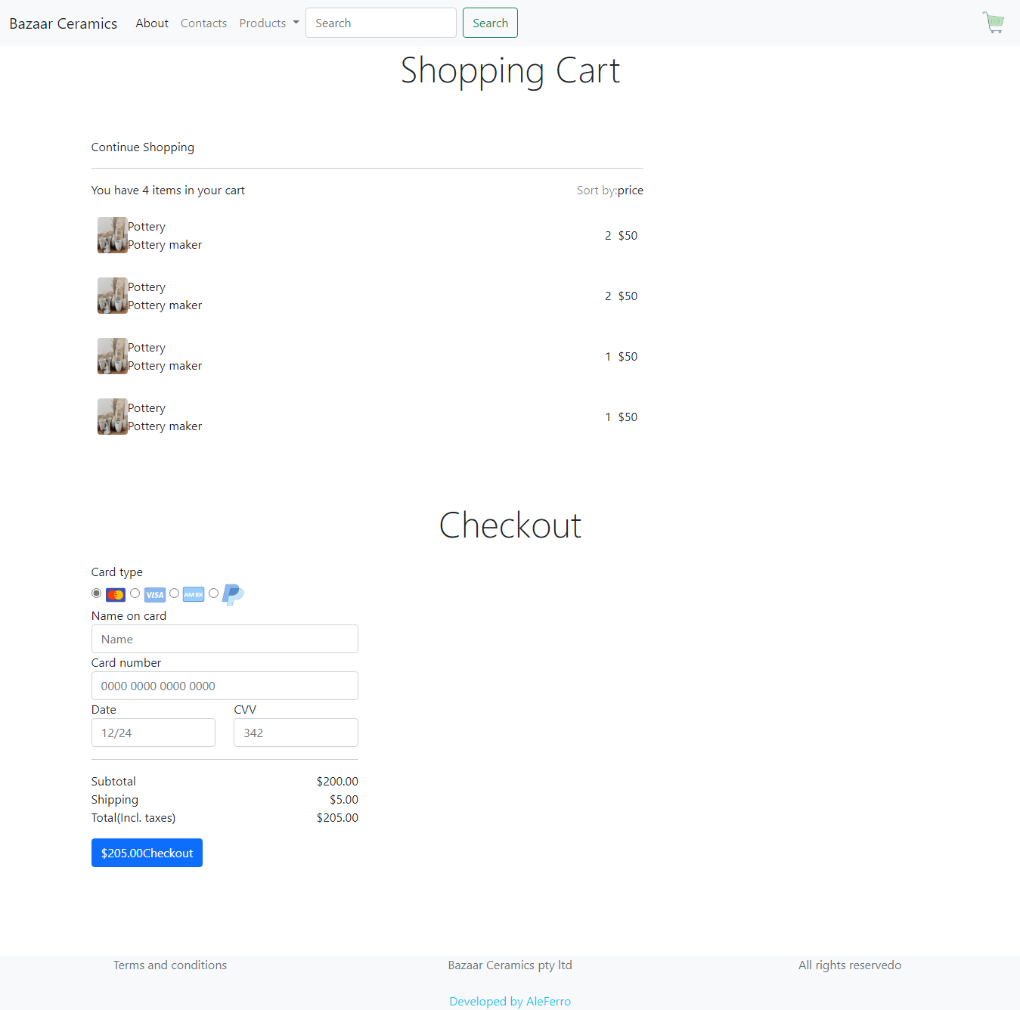

2.5

Investigate processes for interface methods, to identify interface options based on data flow i.e. data from one system to another.

**Answer**

When an application needs data, it presents to the user an interface to collect them. There are several processes that may require data input from the user:

* Add/update/remove item
* Require sales report
* Checkout
* Create account
* Login

All this processes allow a user to enter data and submit them to the system. The data captured may need to be stored in a database, or sent to another application or system.

To achieve this, the application needs to communicate with an API that exposes methods to send or receive data.

2.6

Produce an evaluation document that include: performance or speed of the system, quality, environment requirements or business rules, size, ease of use, reliability, robustness and portability.

**Answer**

* **Performance**

Pages load shouldn’t take more than 3 seconds. Loading time optimization is an important factor for any web application, but it becomes crucial for ecommerce websites, where it can affect the decision for customers to leave or stay. A lot of research has been conducted and all the data confirm that even only a second of delay in rendering a page to the customer can cost the companny a significant amount of money.

To keep loading time in a reasonable range, the company can consider:

* + Files structure and code optimized for speed
  + Fast hosting service
  + The use of a CDN
  + Keep calls to external resources to a minimum
  + Thorough testing on mobile
  + Balance the amount of data required for each page to work properly. Sometimes it’s better to use two fast pages, instead of just a slow one
  + Review code for unnecessary use of iteration controls that may slow down program execution
  + Optimize images sizes and numbers.
  + Avoid using slides
  + Keep the web application simple.
* **Quality**

The solution should be wriiten with respect of modern standards and best practices.

* + User interface design must reflect modern trends
  + Responsive design. A mobile first approach is advised
  + Simple navigation
  + Code should include, but not overuse commments
  + Code should be reviewed and optimized
  + Code should be organized according to a design pattern
  + Comprehensive and clear documentation should be comprehensive.
* **Environment requirements or Business rules**

The website should implement all the design choices and functionalities relevant to accomplish the functions expected from an ecommerce website. Visitors should be able to browse the company’s products, register and login to the website, add prodcuts to cart and purchase the items.

Website administration functionalities are also needed, to allow admin staff to manage customers and products.

* **Size**

The database should have a minimum size of 5GB

* **Ease of use**

In line with modern trends, user experience should aim at simplicity. The website should be planned to favour minimal navigation, minimal interaction required to the customer and specific and relevant information displayed on screen

* **Reliability**

Thorough testing pre-deployment should be performed to ensure the that functionalities, data handling and data integrity are as intended.

Back up should be performed daily.

A disaster recovery paln should be implemented to guarantee business continuity.

* **Robustness**

Security measures should be in place to ensure the protection of the system and the data handled.

encryption protocols, authentication and authorization routines and network security software should be implemented on top of continuous testing and software maintenance.

* **Portability**

The website source code should be stored in an online repository.

3.1

After assessment of business problem now develop the "solution" that is just a description, model or prototype of the solution.

**Answer**

Refer to attached file

3.2

You need to determine the cost of business solution based on requirements determination. Then cost and initial solution will then be presented to the client for feedback.

**Answer**

Cost of the solution: AUD 2.500,00

The cost covers:

* Domain
* Server
* Code
* Documentiation

3.3

To use modeling techniques investigate systems hardware, network infrastructure, operating's system, application architecture, internal/external interface requirements/protocols, the development tools and industry standards or guidelines.

**Answer**

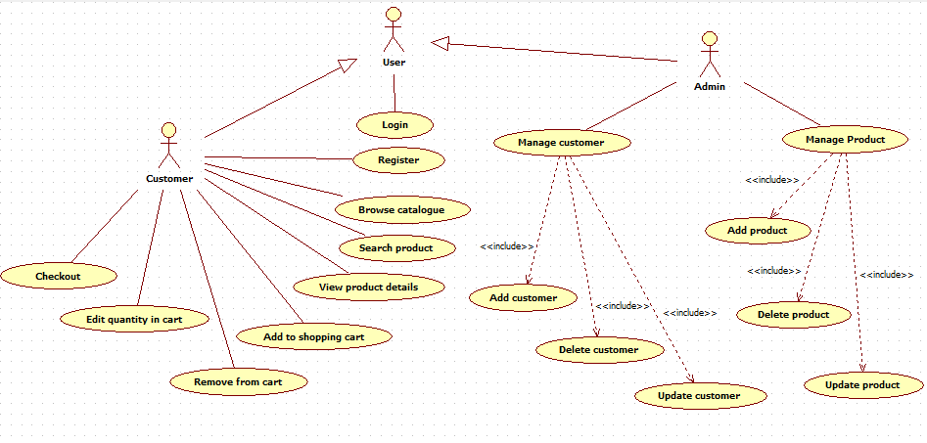

* The application will be hosted on a web server
* OS: CentOS
* Database: MariaDB
* Communication protocol: HTTP
* Internal/external interface: MariaDB API, Paypal API
* Development tools: VSCode, Xampp
* The application will be developed in accordance to modern standards of quality.

3.4

The purpose of the report document is to communicate and confirm the requirements. Defines the areas that the new system will improve and any topic that may impact on the project.

**Answer**

The purpose of the report is to analyse the business and its requirements in relation to the technical solutions possibly offered by the new system.

It takes in cosideration the business problem, or opportunity, the existing infrastructure, the stakeholders’ requirements and the environment in which the system operates and details how the new implementation proposes to address each one of those aspects.

The element of a report ususally are:

* Scope and objective - state the purpose, or the goal the system proposes to achieve.
* Functional reuqirements – detail the interaction of the users with the system and their implementation
* Non functional requirements – metrics about the perfomrances and behaviour of the system, non strictly related to interaction with the user.
* Development methodology – Agile
* Deliverables – product and documentation that will be handed over to the client at the end of the project.

A report is a valuable tool that can be used as a mean of communcation between developers, managers and client to analyze the system and identify areas of improvement, or areas that may need a more in depth discussion.

4.1

This last of involves validation of requirements, evaluation of requirements. The client checks it to ensure it meets expectations and provides feedback accordingly.

**Answer**

Once the report is completed, the client is expected to review it and to provide feedback. Client feedback is extremely important for the success of a project. According to the Chaos Report from the Standish Group, poor client involvement is the leading cause for the failue of IT related projects. The client should be involved and consulted since the initial phases of a project, using the feedback as the guidline on which base the project evolution.

4.2

Depending on feedback changes may need to be incorporated into the requirements definition and so on until agreement is reached.

**Answer**

Work on a project happens in cycles. Work on the project begins (be it requirements gathering, desigin, prototyping, development or testing), the client provides feedback, the feedback is integrated in the project and new feedback is provided by the client.

Work 🡪 Client feedback 🡪 Feedback integration 🡪 Client Feedback 🡪 Integration 🡪 etc.

It’s common that an IT project evolves from the initial requirements. When a pure concept starts to take form, new challenges or needs that haven’t been previously foreseen can appear and the project can take a different direction. In this scenario it’s easy that each person involved in the project devleop a personal view of where the project is going, different from the initial one and also different from that of the others.

Iterating through a cycle of feedback and integration is the most efficient way to keep everyone in sight of the same goal and to ensure that this goal is in line with the client expectations, until an agreement is reached.

4.3

Document the evidence of changes incorporated as per client feedback and prepare final report for agreement.

**Answer**

Any change implemented in the system as per client indication, must be properly documented. It may be a simple change in the UI or the addition of an entire new functionality, but what happens in the project should always be mirrored in the documentation.

Once the requirements are defined and there is full agreement from both sides, the final report can be produced for the client to verify and sign-off.

4.4

Obtained client sign off on the developed requirement document that provides a formal agreement between the client and the developer of the system.

**Requirements Sign Off document**

Project Name:

Client Name:

Approving client representative:

Development studio:

Development studo representative:

|  |  |
| --- | --- |
| **Deliverable** | **Notes** |
|  |  |
|  |  |
|  |  |
|  |  |
|  |  |
|  |  |
|  |  |

Signed by the client Signed by the development studio

Date Date

Reference

Ecommerce performance - <https://www.shopify.com.au/enterprise/site-performance-page-speed-ecommerce>

<http://uniinstitute.com.au/ica50615/8_respak/tocmenu/respak_index.htm>

<https://www.standishgroup.com/sample_research_files/CHAOSReport2015-Final.pdf>